1]

package javaapplication7;

import java.io.IOException;

import java.nio.file.Files;

import java.nio.file.Path;

import java.nio.file.Paths;

import java.nio.file.StandardCopyOption;

public class JavaApplication7 {

public static void main(String[] args) {

Path p = Paths.get("C:\\java programs\\New folder\\backup");

Path p1 = Paths.get("scores");

Path p2 = Paths.get("backup");

Path p3 = Paths.get("sample.txt");

Path woD = p.resolve(p1);

Path woF = p.resolve(p1.resolve(p3));

Path buD = p.resolve(p2);

Path buF = p.resolve(p2.resolve(p3));

try {

if(Files.exists(woF)){

if(Files.notExists(buD)){

Files.createDirectories(buD);

}

Files.copy(woF, buF, StandardCopyOption.REPLACE_EXISTING,

StandardCopyOption.COPY_ATTRIBUTES);

}

if(Files.notExists(woD))

Files.createDirectories(woD);

if(Files.notExists(woF))

Files.createFile(woF);

}

catch (IOException x) {

System.err.println(x);

}

}

}

**Output:**

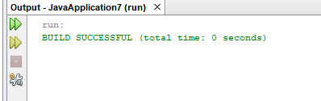

2]

package javaapplication11;

import java.util.InputMismatchException;

import java.util.Scanner;

public class JavaApplication11{

static int getAge() {

int age = -1;

Scanner in = new Scanner(System.in);

try {

System.out.print("Please enter your age: ");

age = in.nextInt();

} catch (InputMismatchException e) {

System.err.println("Invalid input. Please enter a valid age.");

} catch (Exception e) {

System.err.println(e);

} finally {

if (in != null)

in.close();

}

return age;

}

public static void main(String[] args) {

int age = getAge();

if (age != -1) {

System.out.println("You are " + age + " years old.");

} else {

System.out.println("Age not entered.");

}

}

}

**Output:**

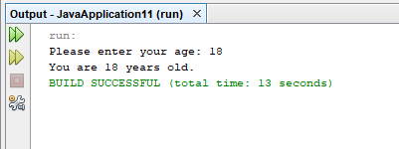

3]

package javaapplication10;

import java.io.BufferedReader;

import java.io.IOException;

import java.io.InputStreamReader;

public class JavaApplication10{

private static String readLine() {

String line = "";

InputStreamReader isr = new InputStreamReader(System.in);

BufferedReader in = new BufferedReader(isr);

try {

line = in.readLine();

}//end try

catch (IOException e) {

System.err.println(e);

}//end catch

return line;

}/

public static void main(String[] args) {

System.out.print("Enter a line: ");

String input = readLine();

System.out.println("You entered: " + input);

}

}

**Output:**

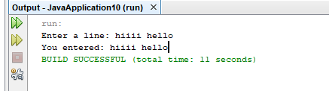

4]

package javaapplication12;

import java.io.BufferedReader;

import java.io.FileReader;

import java.io.IOException;

public class JavaApplication12{

private static String readFile() {

try (BufferedReader br = new BufferedReader(new FileReader("C:\\java programs\\sample.txt"))) {

StringBuilder fileContents = new StringBuilder();

String line = br.readLine();

while (line != null) {

fileContents.append(line);

fileContents.append(System.lineSeparator());

line = br.readLine();

}//end while

return fileContents.toString();

} catch (IOException e) {

System.err.println(e);

return null;

}

}

public static void main(String[] args) {

String fileContent = readFile();

if (fileContent != null) {

System.out.println("File contents:");

System.out.println(fileContent);

} else {

System.out.println("Error reading file.");

}

}

}

**Output:**

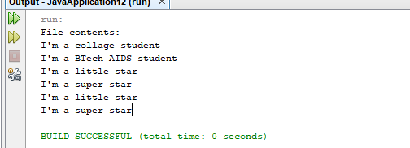

5]

package javaapplication13;

import java.util.Scanner;

public class JavaApplication13 {

public static char[] readEntry() {

Scanner scanner = new Scanner(System.in);

String inputString = scanner.nextLine();

return inputString.toCharArray();

}

public static void main(String[] args) {

StringBuffer sb = new StringBuffer();

char[] input;

System.out.print("Enter a string: ");

input = readEntry();

for (int i = 0; i < input.length; i++) {

if (input[i] != '\n' && input[i] != '\0')

sb.append(input[i]);

}

System.out.println(sb);

}

}

**Output:**

